Task 2

**Phase 1**

the game that I want

1. **Target Device:**

* The target device for the game is targeted for a Windows PC because the mouse is being used to slice the fruit.

1. **Gameplay Flowcharts**

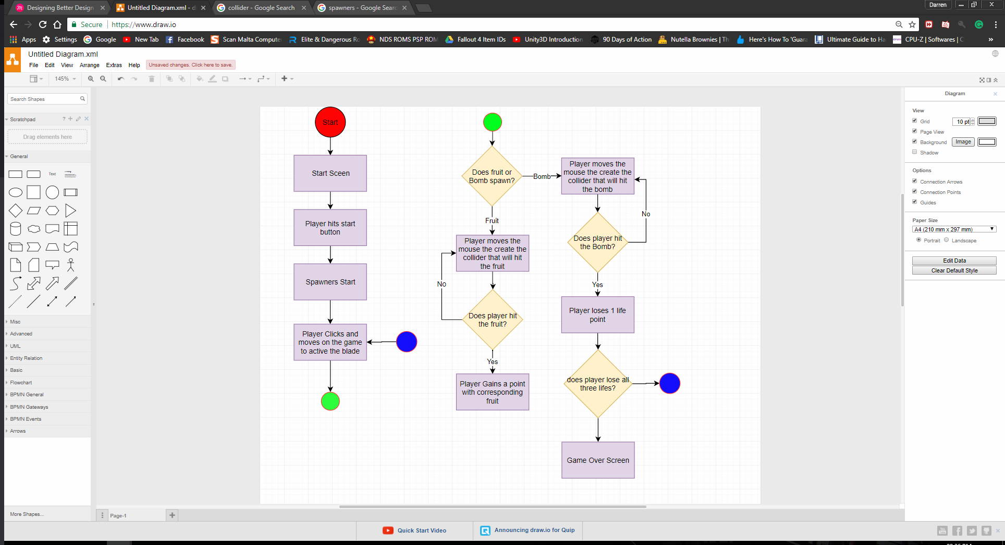

1. **Game Mechanics**
   * The Slicing of the blade
   * The use of the slicing of the blade to hit the fruits
   * bombs that spawn with the Fruits to lower the user’s life points.
2. **Game Objectives** 
   * The objective of the game is to get as much score as possible by slicing three different fruits that have different points and avoiding bombs that spawn. The watermelon the largest of the group has 1 point, the apple the medium sized fruit has 2 points and the smallest of them all the strawberry has 5 points.
   * The player has 3 lives if the player hits a bomb he will lose one live. When the player has no more lives the game is over.
3. **Visual Assets (2D/3D)**
   * Each fruit has a different model that corresponds to them, they also have the sliced version to each fruit.
     1. 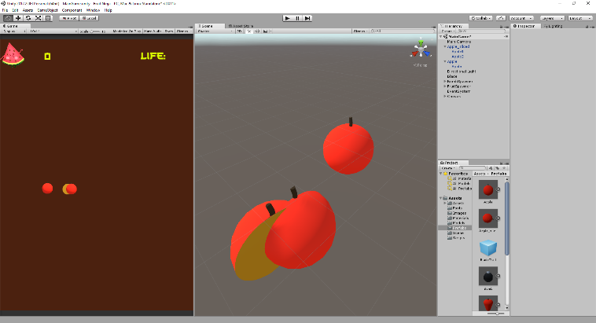Apple

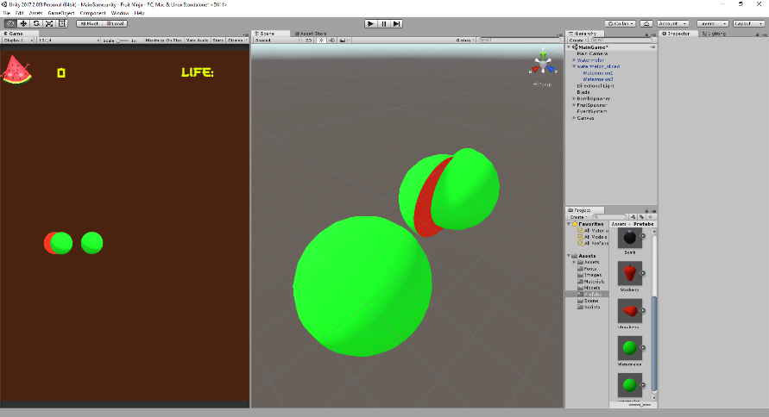

* + 1. Watermelon

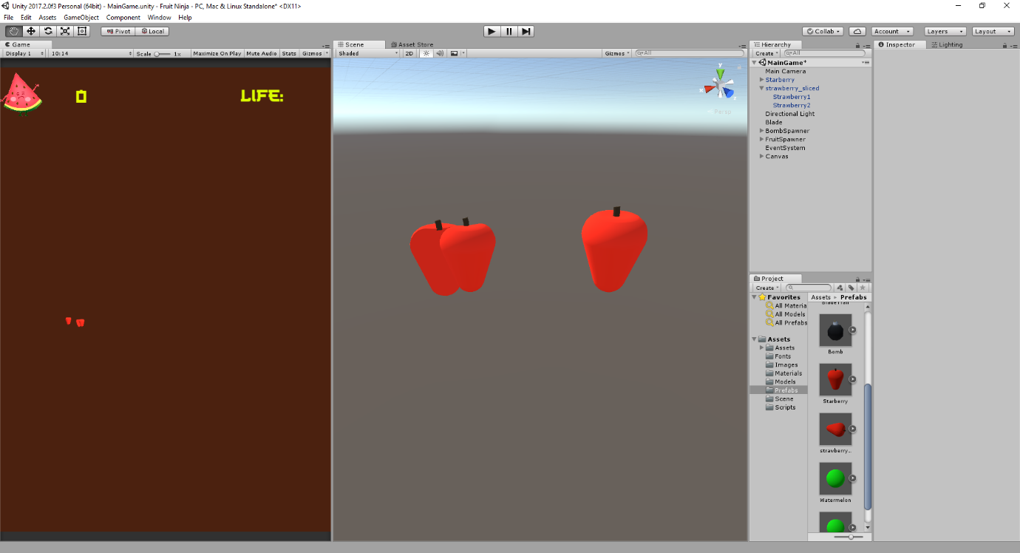

* + 1. Strawberry
  + The bomb also has a model with it but when the player hits the bomb a particle system is added to have a nice effect

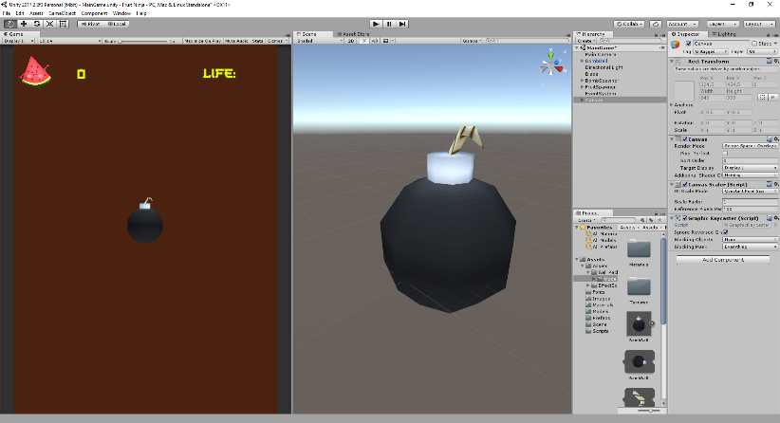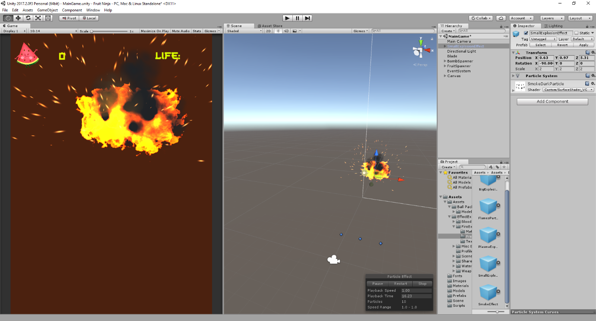

1. **UI Elements**
   * UI Elements for the game will consist of the score system and a live counter

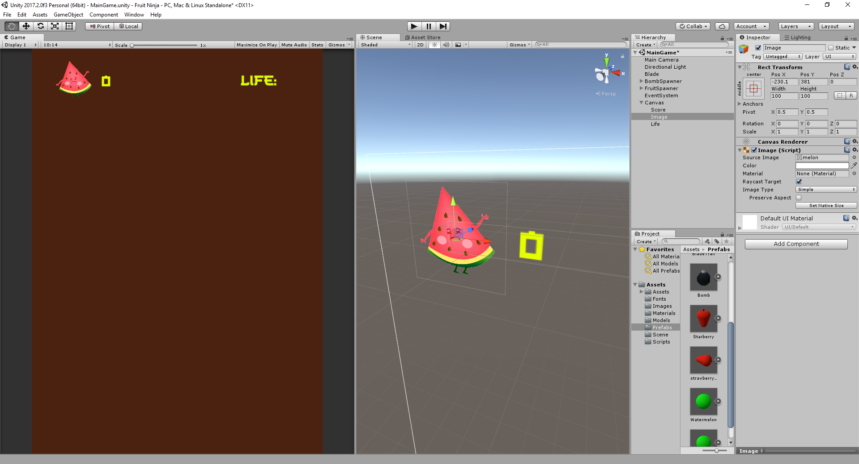

1. **Game Scenes**
   * The game will have 3 scenes the Start Menu when the game opens up
   * The actual game that the user will be playing
   * The game over Scene when the player loses all his live’s

**2**

* GitHub Repository

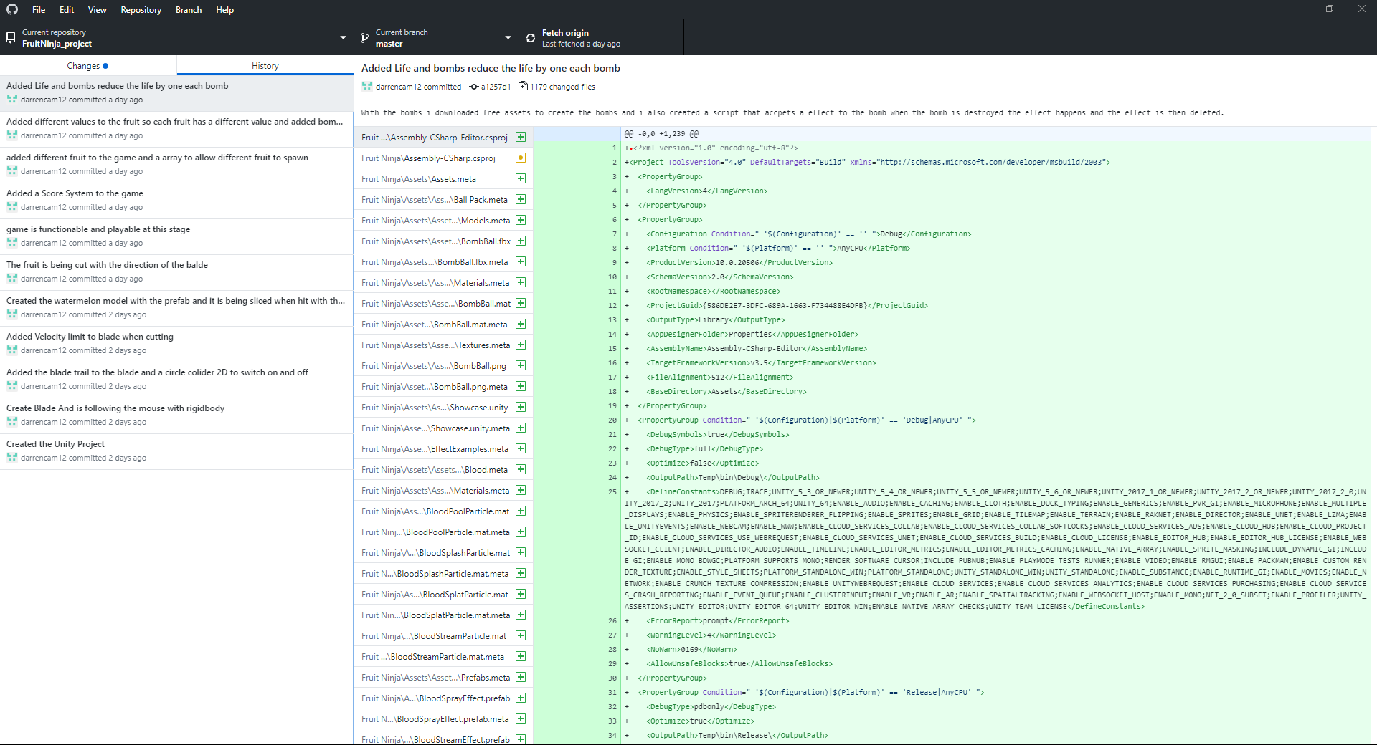

**3**

* 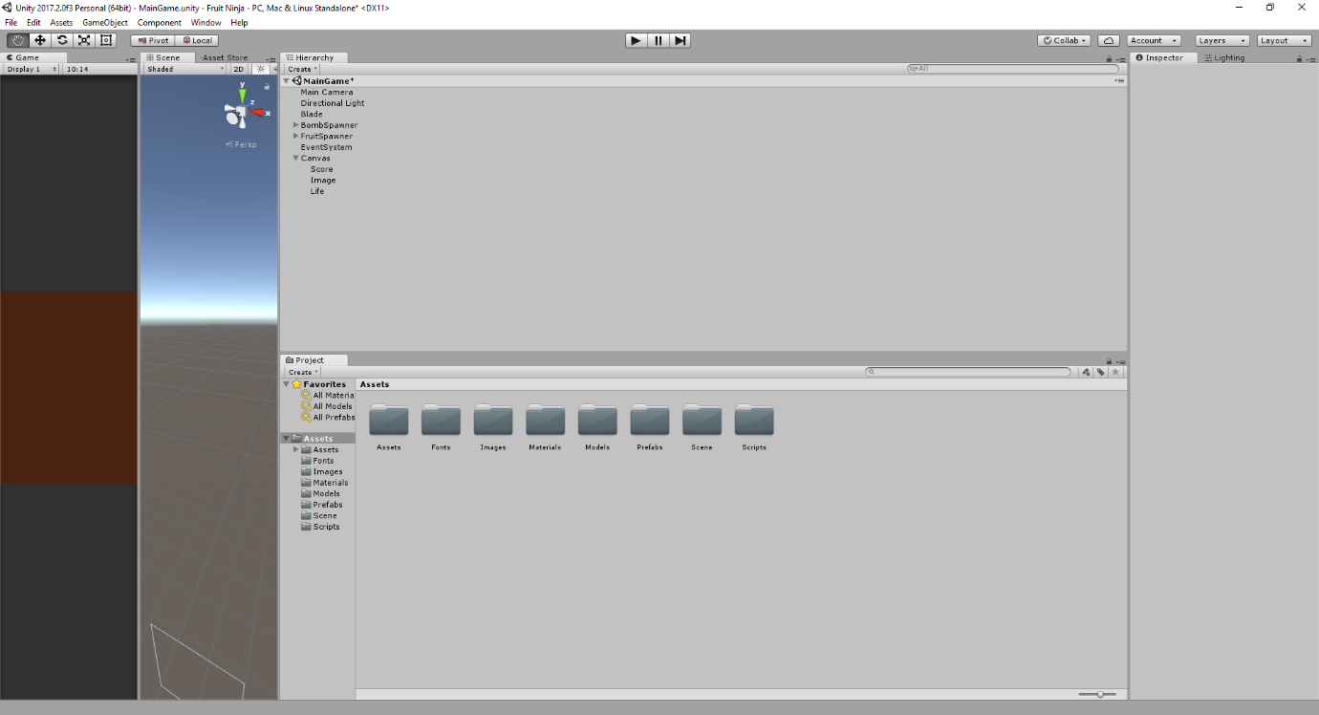All Assets in the game folder